**CSE541 Computer Vision**

**Prof. Mehul Raval**

**Gaze Tracking**

**Week 5 Report**

| **Name** | **Enrolment Number** |
| --- | --- |
| Nityam Dixit | AU2040140 |
| Devyash Shah | AU2040152 |
| Kavan Gondalia | AU2040030 |
| Kush Patel | AU2040137 |

### Task performed this week

Improvised traditional algorithm

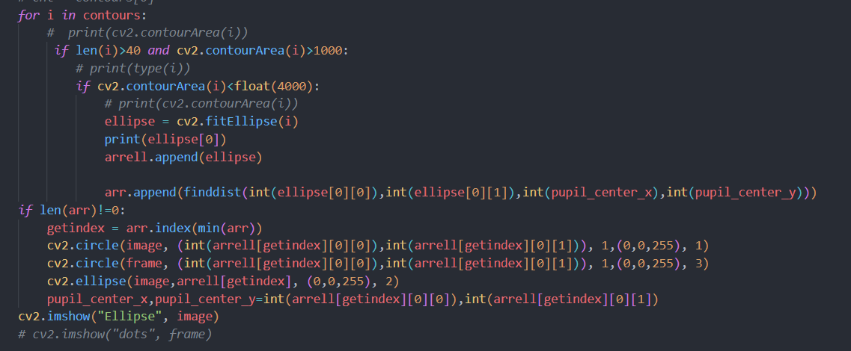

We were getting multiple ellipses in a single frame after using the initial method. It is best to choose the single ellipse from the prior frame. Here, we save all the ellipses in an array, compare them to the prior frame’s elliptical centre, and find the least distance ellipse is selected. And each frame follows the earlier frame’s centre.

### Annotations

We tweaked an annotation tool(written in python) to get the ellipse coordinates and fit an ellipse from the boundary points.

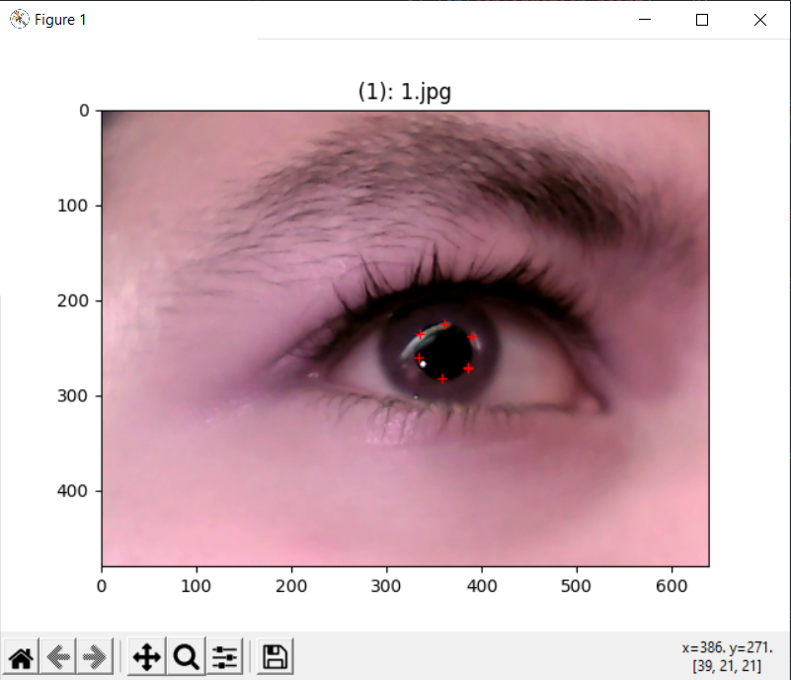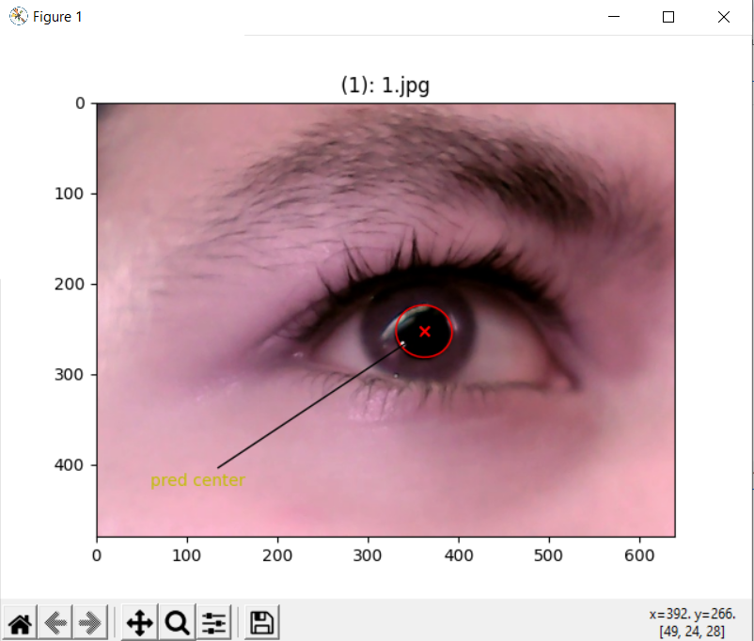

We get files in a .txt format.

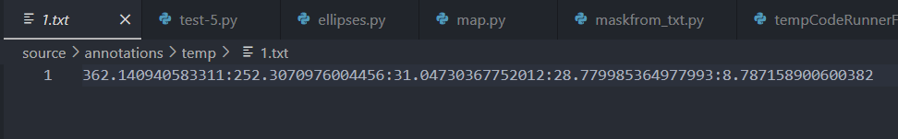

“1.txt” contains the centre points (x,y), height, width and the angle for the ellipse. (Basically the equation for the ellipse)

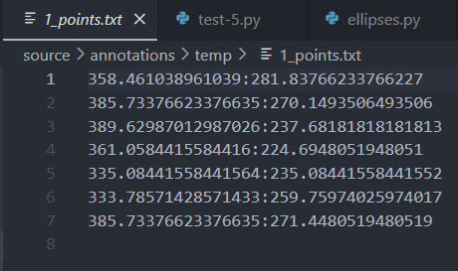

“1_points.txt” contains the boundary point we clicked in the annotations tool. Cv2’s fitellipse function uses boundary points to fit the ellipse.

### Collecting data

We collected our data on our hardware.

[Hardware:

We have finally used an IR-led for taking the videos. That does not create flickers in the video. Overall improving the traditional method of finding ellipses quickly.

The component used:

<https://evelta.com/flat-top-infrared-ir-led-940nm-4mw/>

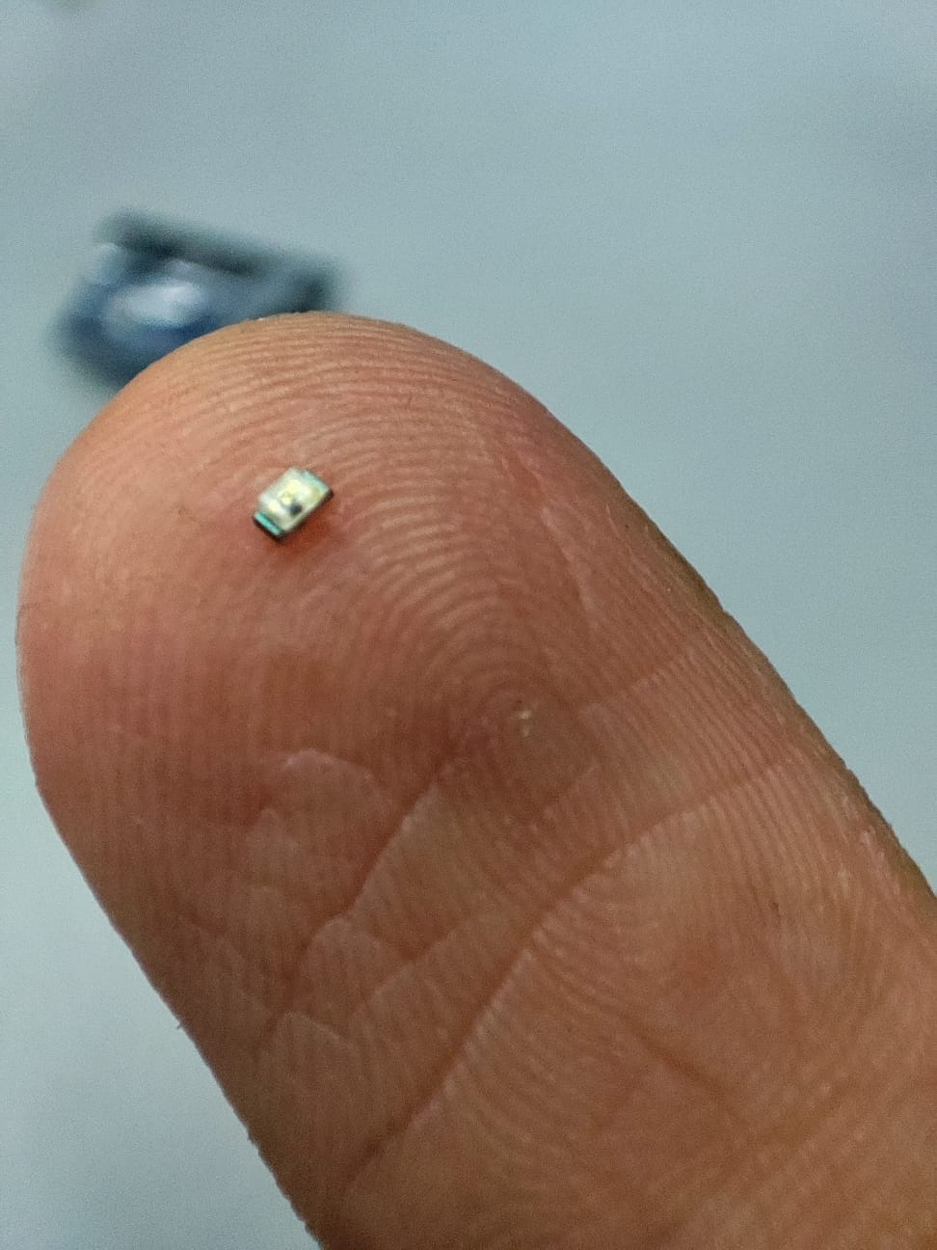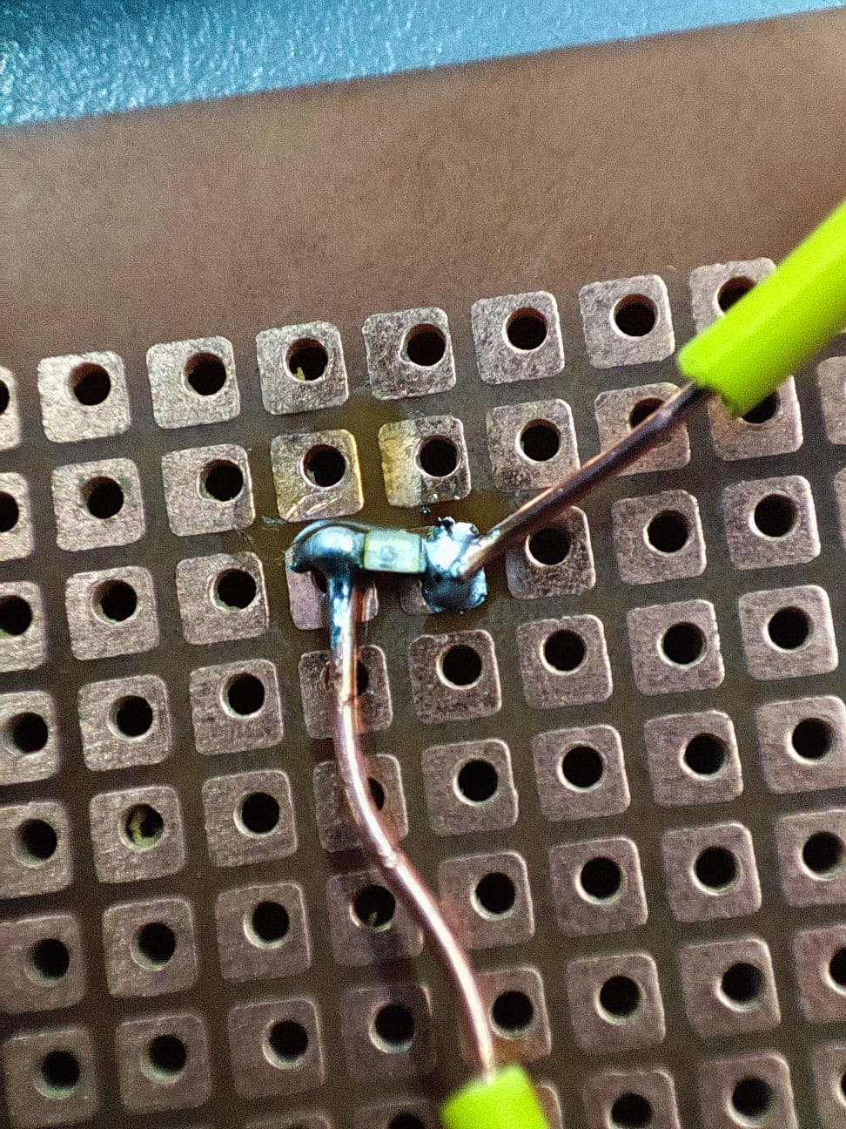

]

We collected 1 min videos[almost 1800 frames, removing unnecessary framed and only considering meaningful frames: 900 frames/ video] of 7 colleagues which can be further used.

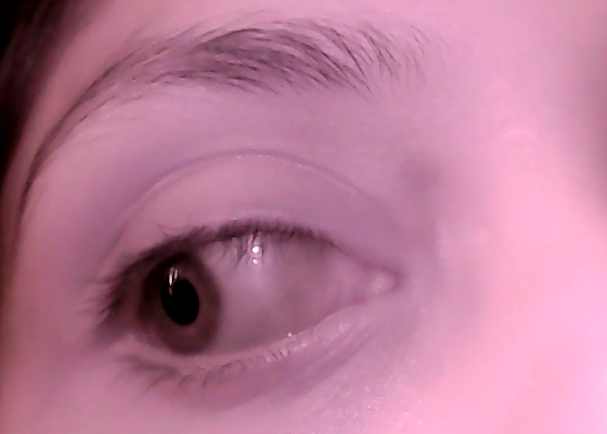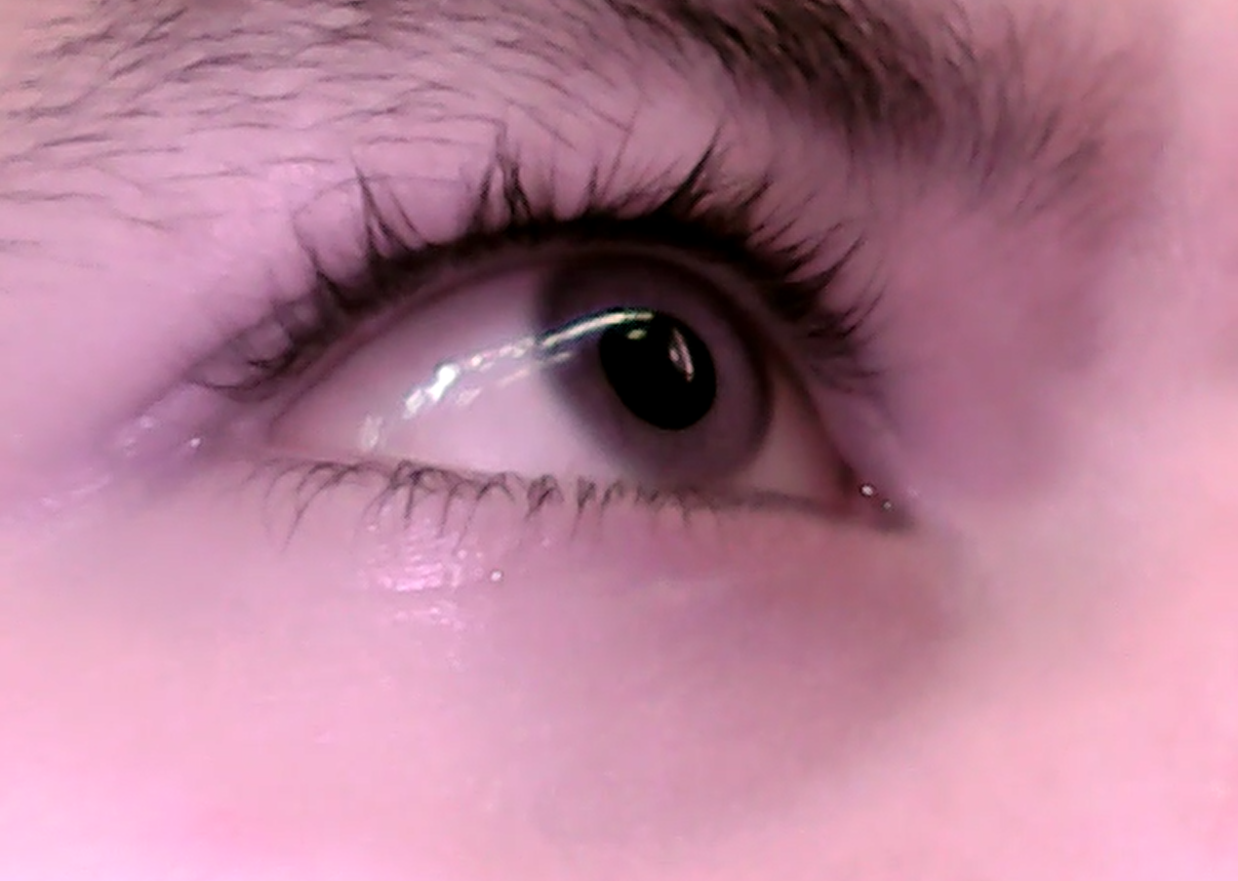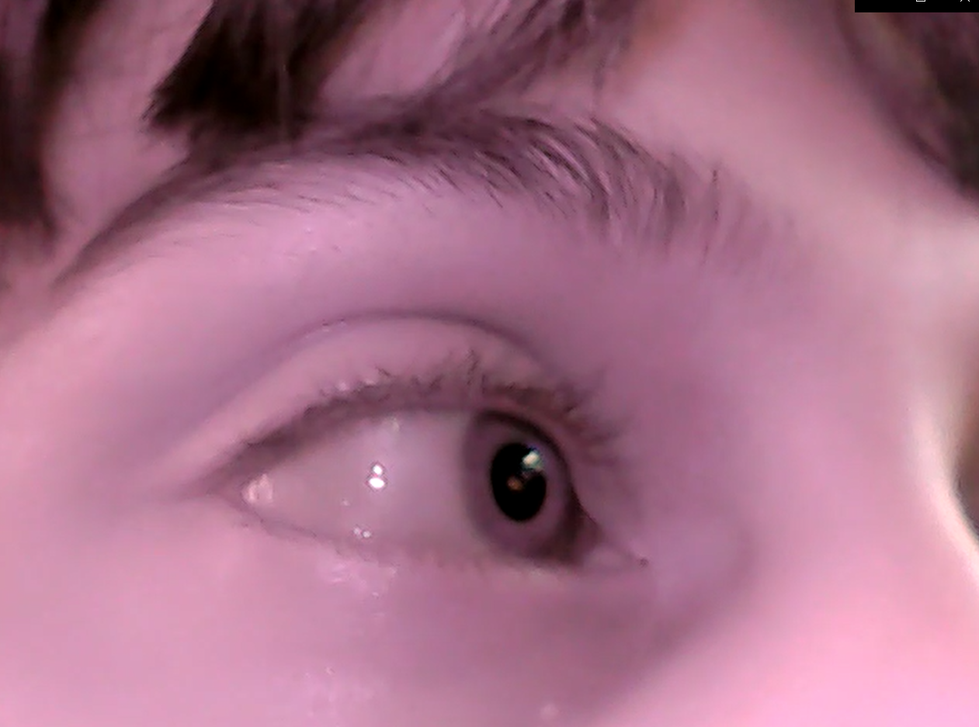

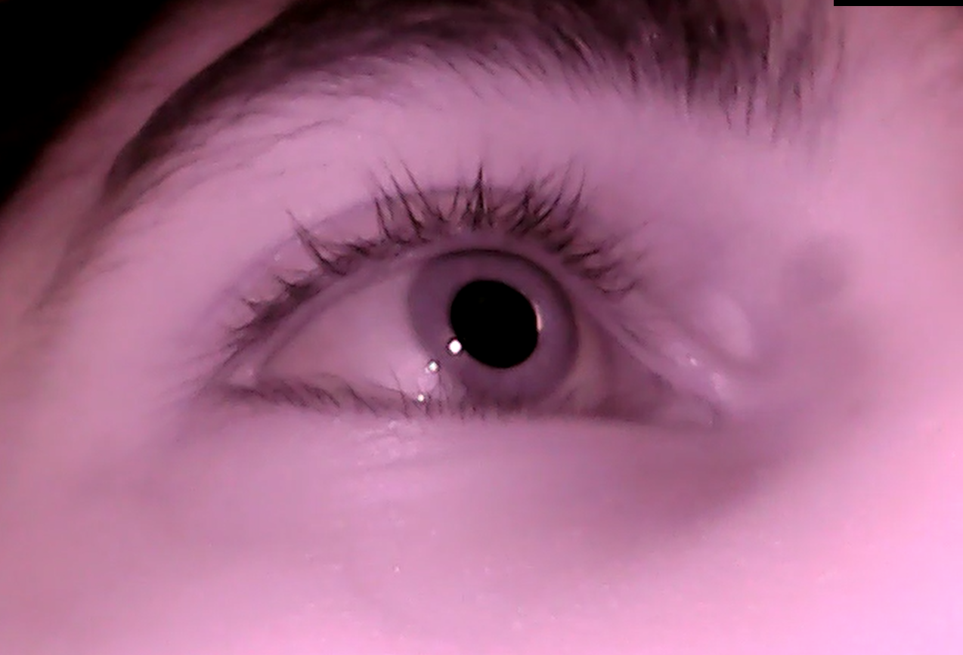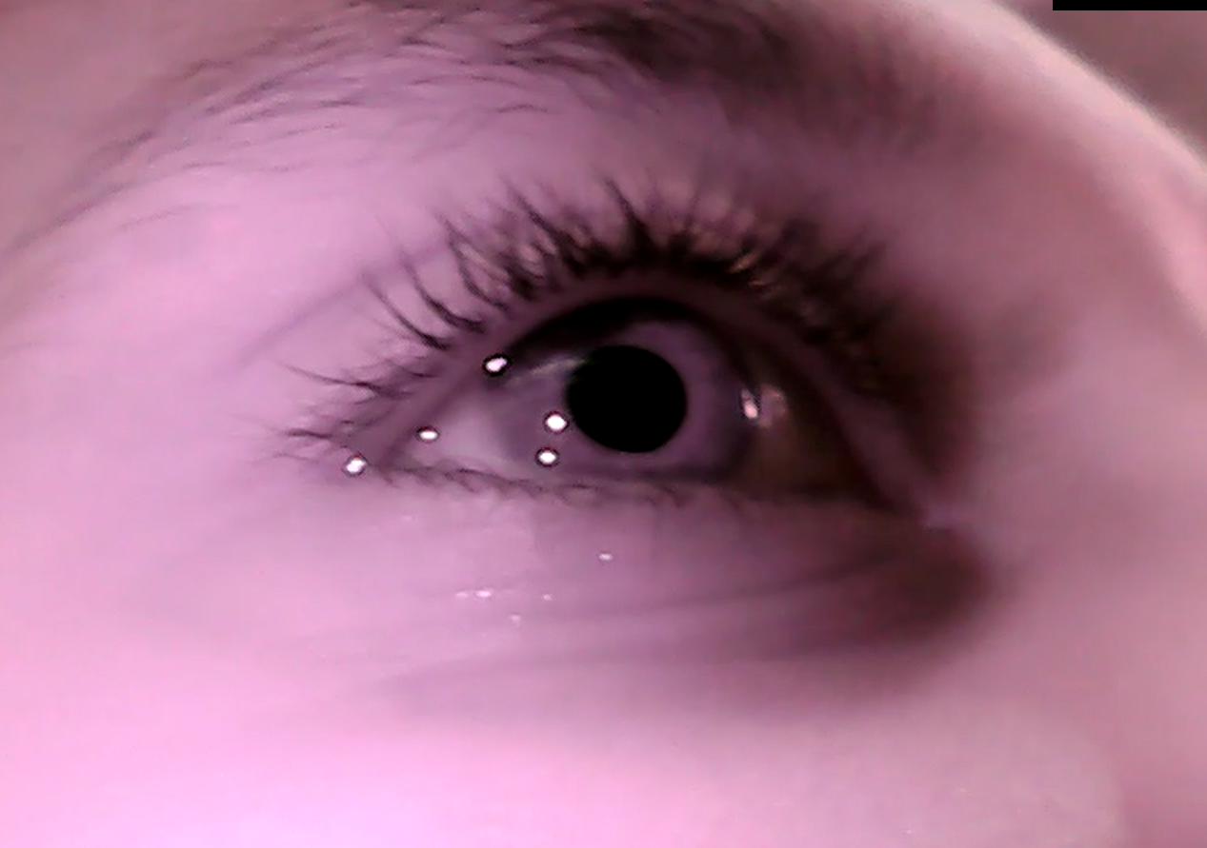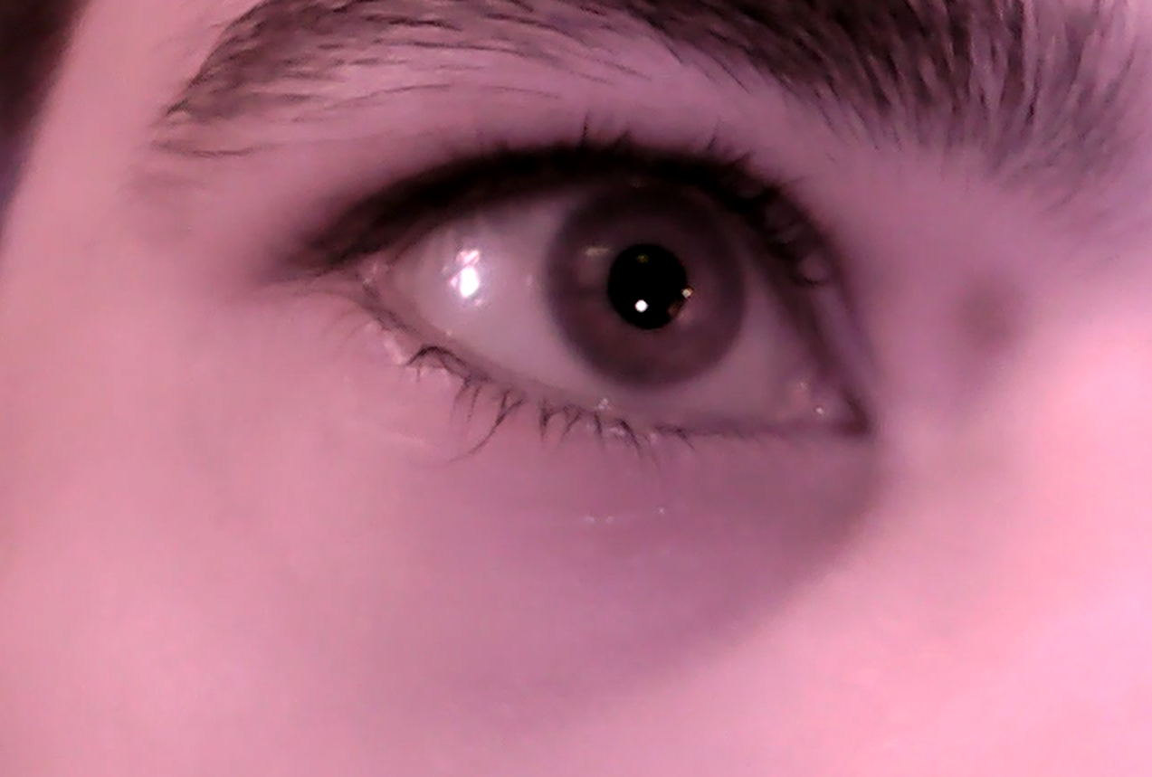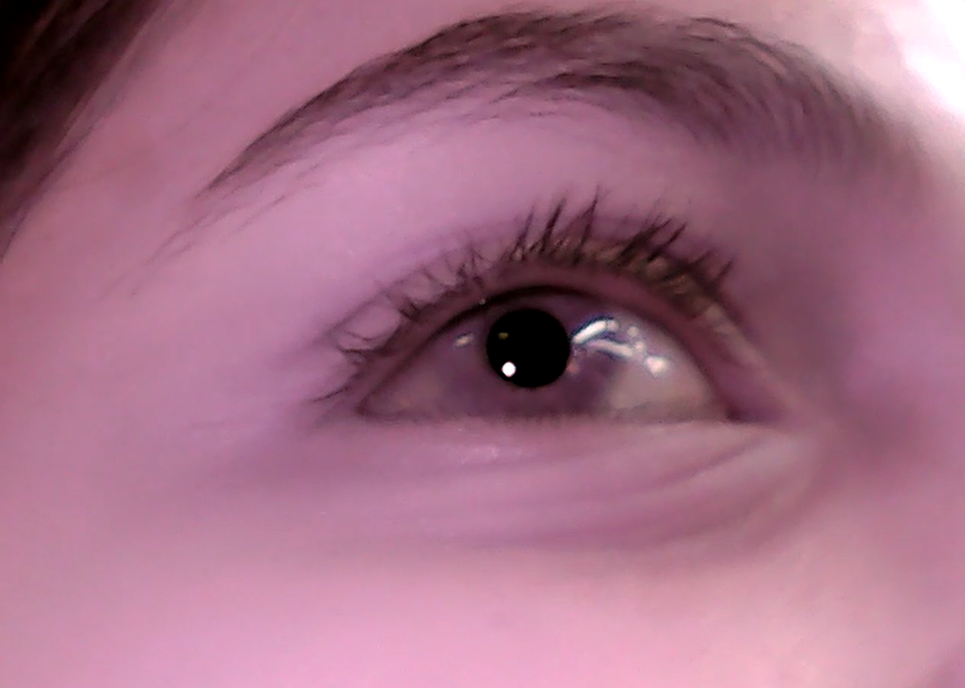

Using these videos on the current method gives a good result. But a lot of miss identification is there. The primary reason is that the threshold cannot differentiate between the dark pupil and equally dark eyelashes. And the shadow because of the position of the light source.

### Binary segmentation using U-net

U-net uses input images and an input mask of the same dimension as the image to train the model. It is a very famous architecture in medical image semantics segmentations.

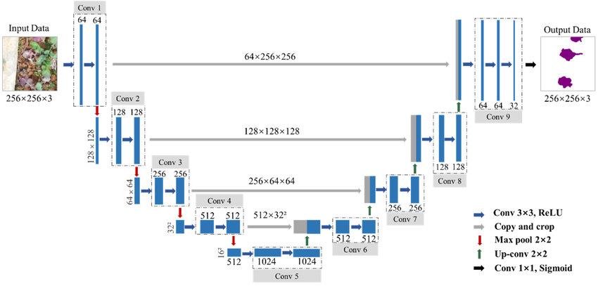

The architecture of the U-net

### Future Work

* Annonating data for the CNN.
* Create a script to generate the masks from the annotated points.
* Fit the model and try different optimisation techniques.
* Figure out how to calculate the gaze direction. The current consideration is to use eye movements in a single plane, which makes the maths easy to calculate. But we do not have any estimation of the accuracy of that.
* Another method is to consider the eye as a sphere, which requires the traced 2D points to transform as the points of a sphere. The centre of the sphere would be the eye’s centre, and the vector connecting the centre to the point on the sphere would give the gaze direction.